**Real-Time D4PG-Based Control Algorithm for Hip Exoskeleton Motion Assistance: Action Intention Detection During Fatigue**

Hung-Ta Lai1, En-Yu Shen1, Yun-Ting Liu1, An-Yu Huang1, Yu-Chun Lo2*, and You-Yin Chen1, 2*

1 Department of Biomedical Engineering, National Yang Ming Chiao Tung University, Taipei, Taiwan

2Ph.D. Program in Medical Neuroscience, Taipei Medical University, Taipei, Taiwan

*Email: [aricalo@tmu.edu.tw](mailto:aricalo@tmu.edu.tw) /[youyin.chen@nycu.edu.tw](mailto:youyin.chen@nycu.edu.tw)

**INTRODUCTION**

Prolonged physical activities, such as hiking, can lead to significant muscle fatigue in elderly individuals, which poses serious safety and health risks. Muscle fatigue not only diminishes performance but also increases the likelihood of injuries, particularly falls, which are a leading cause of morbidity in older adults [1]. To mitigate these risks, our exoskeleton system is designed to reduce the intensity of specific muscle usage and prolong the duration of physically demanding activities, thereby enhancing overall safety and efficiency. The integration of advanced technologies, such as exoskeletons, has shown promise in providing necessary support to elderly users, allowing them to engage in activities that would otherwise be too strenuous [1].

Traditional exoskeleton models often depend on rigid motion assumptions, which can limit their effectiveness in dynamic environments where human movements vary significantly. This limitation has prompted the exploration of more adaptive control methods, particularly Reinforcement Learning (RL), which can automate the guidance of the exoskeleton's control model. Unlike conventional approaches, RL allows for real-time adaptation to a wide range of motion patterns without relying on fixed formulas, making it particularly suitable for the unpredictable movements of elderly users [2]. This adaptability is crucial for ensuring that the exoskeleton can respond effectively to the unique needs of each user, thereby enhancing their safety and performance during physical activities.

In our study, we incorporated multiple electromyography (EMG) patches and an Inertial Measurement Unit (IMU) within the exoskeleton to monitor joint angles and capture real-time data. The combination of these technologies enables a comprehensive understanding of the user's movement and muscle engagement, which is vital for effective fatigue management [3]. The real-time data collected from the EMG and IMU feeds into a deep RL model, which dynamically adjusts to the user's gait patterns, specifically targeting muscle groups like the Rectus Femoris (RF) and Biceps Femoris (BF). This continuous learning capability ensures that the exoskeleton can predict the necessary support to alleviate muscle fatigue, particularly during critical phases of the gait cycle [4]. By providing adaptive support during physical activities, our exoskeleton system can significantly reduce the incidence of falls among elderly users, thereby addressing a major public health concern [5]. Furthermore, the ability to mitigate muscle fatigue not only enhances physical performance but also promotes greater independence and confidence in engaging in physical activities, which is essential for maintaining overall well-being in older adults [6].

**METHODS**

The proposed system integrates a RL-controlled hip exoskeleton with real-time detection of muscle fatigue events using EMG monitoring. The exoskeleton aims to assist individuals with PD by detecting fatigue episodes and dynamically adjusting support to improve mobility. The system leveraged the Distributed Distributional Deep Deterministic Policy Gradient (D4PG) algorithm for continuous control of the exoskeleton's actuators, ensuring real-time adaptability to the user's motor state. The corresponding system architecture as follows:

***Exoskeleton Hardware:*** To help the elderly maintain physical functions in daily life, the hip exoskeleton can assist in establishing a neutral spinal posture during walking. By enhancing the strength of the legs and hips, the lower body is better equipped to support the body's weight, reducing the risk of falls due to muscle fatigue and maintaining exercise capabilities. This system has been designed specifically to assist lower limb movement by providing support at the hip joints and corresponding hardware specification and physical human-exoskeleton setup as shown in **Figure 1**.

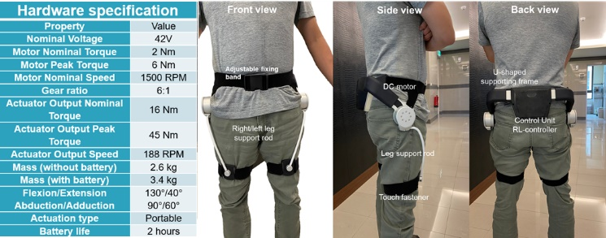

**Figure 1**. **Hardware specifications and wearable setup of the hip exoskeleton system**. The specification sheet outlines key performance metrics including torque, speed, and range of motion, depicting the exoskeleton from front, side, and back views, demonstrating its ergonomic design and positioning on the user’s body for effective support during gait activities.

***Actuators and Sensors:*** The hip exoskeleton was equipped with servo motors to provide controlled assistance. Sensors included IMUs to monitor body posture, and EMG sensors placed on relevant muscle groups (e.g., RF and BF) to capture muscle activity as shown in **Figure 2**. The Cygnus EMG system is a pioneering integration of software and hardware designed for enhancing exoskeleton technology through the precise capture and analysis of EMG signals. These signals, generated by muscle contractions, are accurately detected by high-sensitivity, noise-resistant sensors. The accompanying software processes these signals in real-time, translating human muscle activity into controlled exoskeleton movements for rehabilitative support or enhanced physical capabilities. This system enables a seamless connection between human intention and robotic precision, offering users improved autonomy and efficiency. The dimensions of the dongle connecting to the computer are 6.40 cm × 2.54 cm × 1.50 cm, highlighting its sleek and functional design for seamless integration with EMG systems. Conversely, the dongle that connects to the EMG wires measures 6 cm × 4.78 cm × 1.83 cm, demonstrating the system's compact and efficient component architecture. Additionally, the electrode patches, essential for capturing electromyographic signals, are square-shaped with dimensions of 3.53 cm × 3.53 cm, ensuring precise and comfortable placement on the skin. Four EMG sensors are placed on specific muscle groups relevant to gait, such as the tibialis anterior, rectus femoris, biceps femoris, gastrocnemius muscles of left and right legs as shown in **Figure 2**. These sensors capture the electrical activity generated by muscle fibres during gait movement. Before processing EMG signals, preprocessing procedures were implemented to minimize possible interference. A 10-order Butterworth bandpass filter with the bandwidth of 20-500 Hz was used first employed to reduce possible low-frequency noise artifacts. signals were sampled at a frequency of 1000 Hz. The signals then were segmented into 1000-ms windows for analysis.

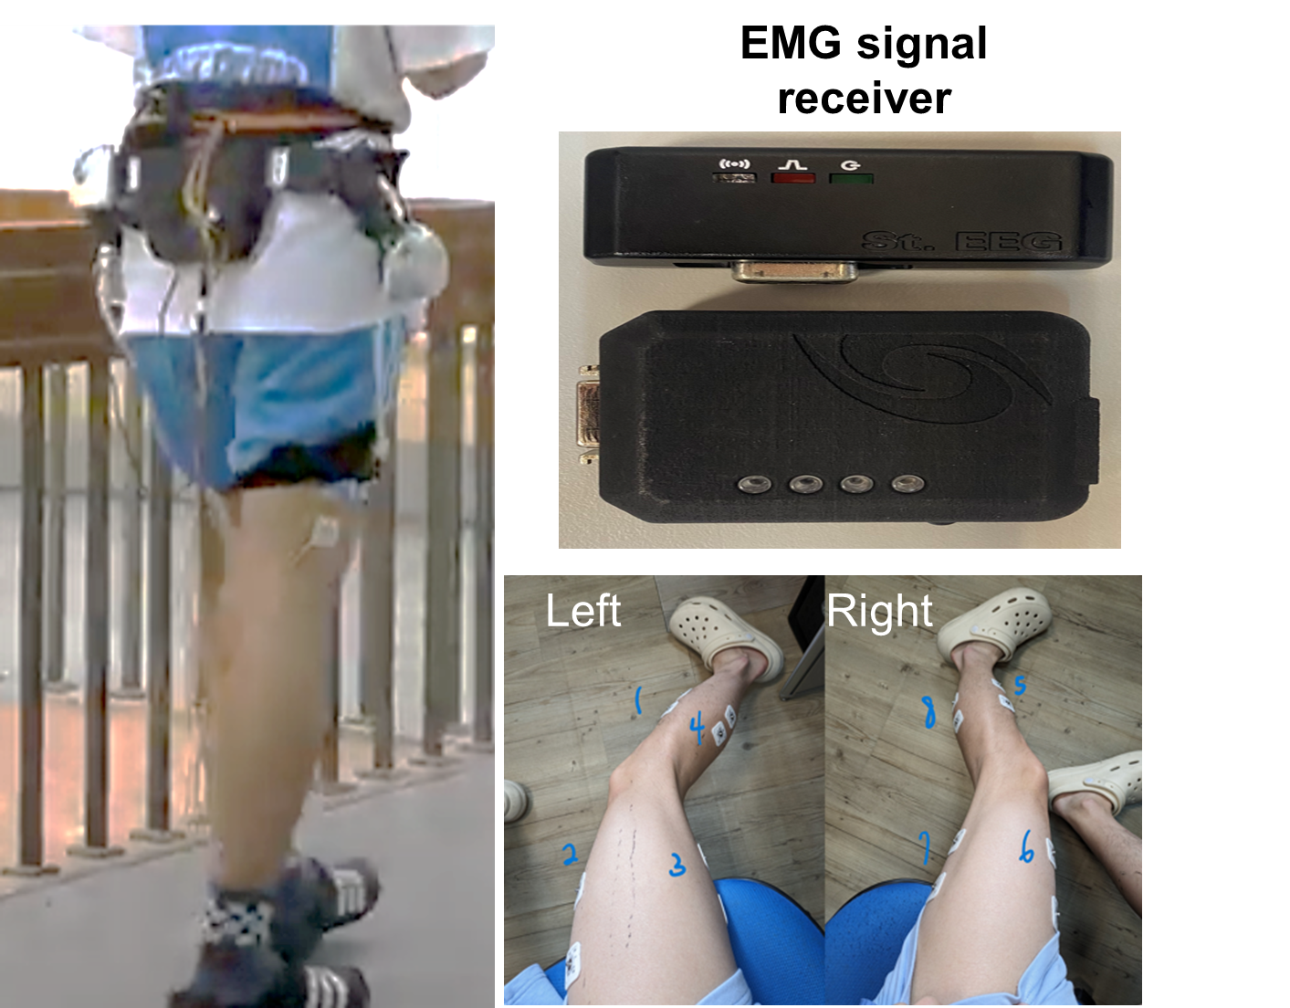

**Figure 2. Experimental setup for EMG-based muscle fatigue detection using a hip exoskeleton**. The left image shows a subject walking while wearing the hip exoskeleton, equipped with four EMG sensors placed on the legs for muscle activity monitoring. The top-right image displays the EMG signal receiver used to collect and transmit the EMG data wirelessly to the processing unit. The bottom-right images depict the precise placement of EMG electrodes on both the left and right legs, targeting specific muscle groups for accurate detection of motor unit activity during gait.

***Distributed Distributional Deep Deterministic Policy Gradient (D4PG) Control[7]:*** We employ the D4PG strategy to detect action intentions and enhance Human-Machine Interaction (HMI) for exoskeleton control. D4PG is particularly well-suited for handling complex tasks, offering superior performance compared to other RL models due to its ability to efficiently process high-dimensional input data and generate precise control outputs[7, 8]. This advantage is crucial in our application, where the exoskeleton must adapt to varying user needs in real-time, especially under conditions of muscle fatigue.

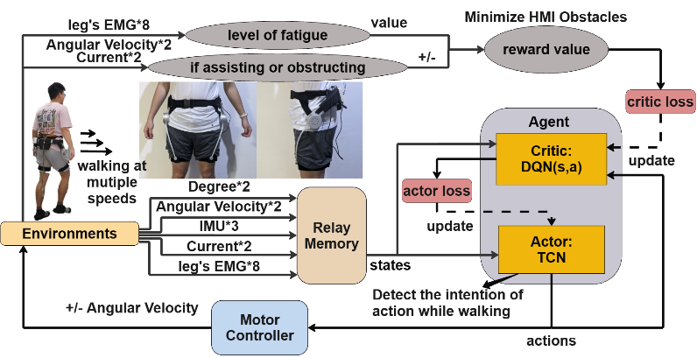

**Figure 3**. **D4PG-based Control System for Hip Exoskeleton**. The system integrates multiple sensors, including leg EMG, angular velocity, and IMU, to monitor the user's gait and muscle fatigue. The data is processed by the TCN acting as the actor, which detects the user's action intentions during walking. The DQN serves as the critic, evaluating the actions proposed by the TCN to optimize the exoskeleton’s performance in real-time. The goal is to minimize HMI obstacles by adjusting motor controller actions based on the level of fatigue and whether the assistance is beneficial or obstructive. The system continuously updates its model through reinforcement learning, ensuring adaptive and precise control during various walking speeds.

In our system as shown in **Figure 3**, the Temporal Convolutional Network (TCN) functions as the actor within the RL framework, responsible for detecting the user’s action intentions during muscle fatigue. The TCN processes input from multiple sensors, including EMG patches and an IMU, to command the motor controller of the exoskeleton, thereby aiding the user’s walking. The Deep Q-Network (DQN) complements this by evaluating the actions proposed by the TCN, using reward signals to optimize the model’s performance. This data-driven approach allows the exoskeleton to continually learn and adapt, optimizing its assistance based on the user's gait patterns and muscle condition.

To validate our hypothesis that the system provides precise control to reduce the burden on the RF and BF muscles during walking, we conducted a comparative analysis using integrated EMG (iEMG) data per gait cycle, both with (*w.*) and without (*w.o*) exoskeleton assistance. The results indicate a significant reduction in muscle activity when the exoskeleton is engaged, demonstrating the effectiveness of our approach.

**RESULTS AND DISCUSSION**

The implementation of our system has shown promising results as shown in **Figure 4**, particularly in its ability to reduce the intensity of specific muscle activities, particularly during phases of the gait cycle where fatigue is most likely to occur. **Figure 4** illustrates the force utilization based on EMG data with the aid of the exoskeleton. The data clearly demonstrates that the exoskeleton effectively reduces muscle activity intensity by predicting subsequent gait patterns, allowing the system to provide timely and appropriate assistance. This reduction in muscle strain is particularly beneficial for users engaged in prolonged physical activities where muscle fatigue can significantly impact both performance and safety.

One of the most significant advantages of our approach is the system's adaptability. Unlike traditional exoskeleton models that rely on predefined motion assumptions, our system continuously learns and optimizes its performance through interaction with the user. This adaptability is facilitated by the TCN’s ability to acquire new weight sets without requiring any mathematical modifications to the existing models [9, 10]. The TCN dynamically updates its parameters based on real-time feedback from the user, ensuring that the exoskeleton’s support is always aligned with the user's current needs. This ability to adapt without the need for extensive recalibration or manual adjustments makes our system highly effective in a wide range of scenarios, including environments that are unpredictable or where the user's movements may vary significantly from one moment to the next.

**CONCLUSIONS**

Our system represents a significant advancement in the field of exoskeleton technology, particularly in its application for reducing muscle fatigue among elderly people's activities. By employing RL in the exoskeleton’s control system, we have developed a solution that not only enhances the flexibility and effectiveness of the exoskeleton but also extends the duration of physical activity without compromising safety. This approach mitigates associated health risks by reducing muscle fatigue makes that our RL-model controlled robotic hip exoskeleton is a promising strategy for increasing the efficiency of human walking because the human hip joint produces large torque during the activities of daily living. By providing targeted assistance that adapts in real-time to the user’s needs, our exoskeleton offers a robust solution that significantly improves both the safety and efficiency of workers in these challenging conditions. Moving forward, the integration of additional physiological signals and further refinement of the RL algorithms could enhance the system's capabilities even further, potentially making it applicable to a broader range of users and use cases.

**REFERENCES**

1. Wang, T., et al., *A Review on the Rehabilitation Exoskeletons for the Lower Limbs of the Elderly and the Disabled.* Electronics, 2022. **11**(3): p. 388.

2. Shore, L., et al., *Exoscore: A Design Tool to Evaluate Factors Associated With Technology Acceptance of Soft Lower Limb Exosuits by Older Adults.* Human Factors the Journal of the Human Factors and Ergonomics Society, 2019. **62**(3): p. 391-410.

3. Chen, J., et al., *Research on Elderly Users' Intentions to Accept Wearable Devices Based on the Improved UTAUT Model.* Frontiers in Public Health, 2023. **10**.

4. Böhme, M., et al., *Evaluation of the Power Deficit of Elderly People During Stair Negotiation: Which Joints Should Be Assisted at Least by an Exoskeleton and With What Amount?* Wearable Technologies, 2022. **3**.

5. Jalal, M.F.A., *Exoskeletons for Elderly Activity of Daily Living Assistance: A Review of Upper Limb Exoskeletons and Assessments.* International Journal of Integrated Engineering, 2024. **16**(1).

6. Cao, Y., et al., *Optimizing Control of Passive Gait Training Exoskeleton Driven by Pneumatic Muscles Using Switch-Mode Firefly Algorithm.* Robotica, 2019. **37**(12): p. 2087-2103.

7. Guo, Y., et al., *DDPG-based controlling algorithm for upper limb prosthetic shoulder joint.* International Journal of Control, 2024. **97**(5): p. 1083-1093.

8. Yuan, Y., et al., *DMP-based motion generation for a walking exoskeleton robot using reinforcement learning.* IEEE Transactions on Industrial Electronics, 2019. **67**(5): p. 3830-3839.

9. Huang, R., et al. *Hierarchical interactive learning for a human-powered augmentation lower exoskeleton*. in *2016 IEEE international conference on robotics and automation (ICRA)*. 2016. IEEE.

10.Chen, S., et al., *Precision interaction force control of an underactuated hydraulic stance leg exoskeleton considering the constraint from the wearer.* Machines, 2021. **9**(5): p. 96.

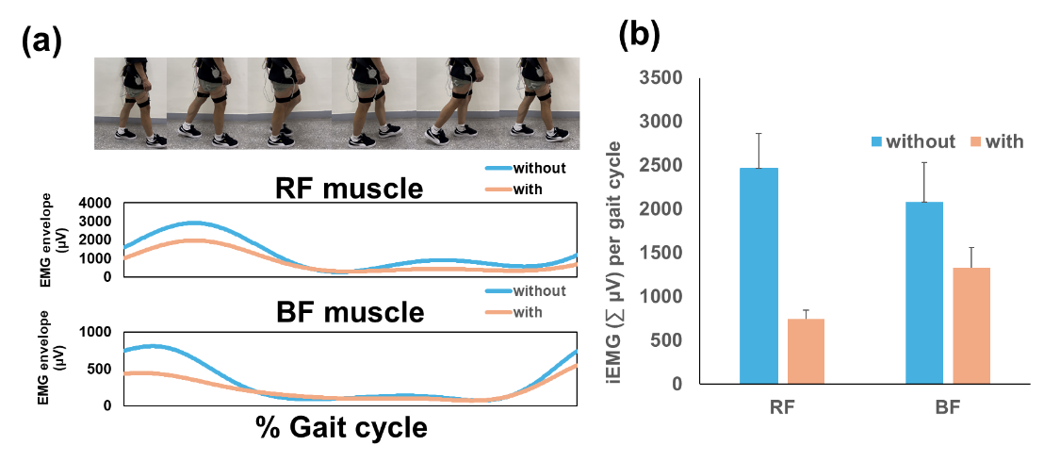

**Figure 4**. **Impact of Exoskeleton Assistance on Muscle Activity During Walking.** (a) The EMG envelopes of the RF and BF muscles are shown during the gait cycle, comparing conditions with (*w.*, orange) and without (*w.o.,* blue) exoskeleton assistance. The data indicates a noticeable reduction in muscle activity when the exoskeleton is used. (b) The integrated EMG (iEMG) values highlight the significant decrease in muscle activity for both the RF and BF muscles when assisted by the exoskeleton, illustrating the system's effectiveness in reducing muscle fatigue.